Kenwood High School’s
School Supply List
We are excited to begin this school year with all of our Kenwood Bluebirds! In order to maximize your potential and success at KHS, we encourage you to have the following supplies with you on the first day of school and every day after that.

- A sturdy three-ring binder
- At least one set of 8-tab dividers
- Pencils
- Blue and/or Black Ink Pens
- Red (or other color) Pens
- Plenty of Notebook Paper
- Highlighters
- Headphones
- A flash/thumb drive
**Note: KHS will provide each student a planner this coming school year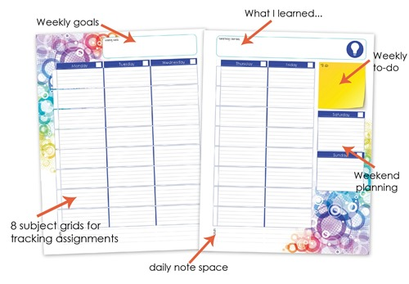
**Students should be sure to bring their BCPS computer & charger to school each day.
Your student’s individual teachers may have other requirements in their course syllabus and those will be communicated during the first days of school. Please contact your students grade level administrator and/or school counselor with any questions or concerns regarding purchasing any school supplies.

Growth Mindset
Enrichment
Academics
Responsibility

